DECLARATION REGARDING TEST EQUIPMENT
No entry to be crossed
- Application/License No. -
- Name/Address:

List of Testing Equipments

I hereby declare that the we don’t have any in house testing facility  I also declare that I will send prior intimation to Bureau of Indian Standards whenever we will convert to large scale and installed a in house lab.  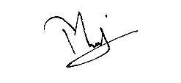  Signature of firm’s representative  Name: -  Designation: -  Date: - 19-03-2025 | I have verified that they don’t have any testing facility in house and they are doing testing from BIS approved lab during my inspection.  Sig. of Bureau of Indian Standards certification officer  Name: -  Designation: -  Date of verification: - 19-03-2025

Note: Attach extra sheet, if required

